POLLIREDDY SRI VARDHAN REDDY

Email: srivardhanreddyofficial1@gmail.com

Cell: +91-8686827827

Top of Form

**Objective** 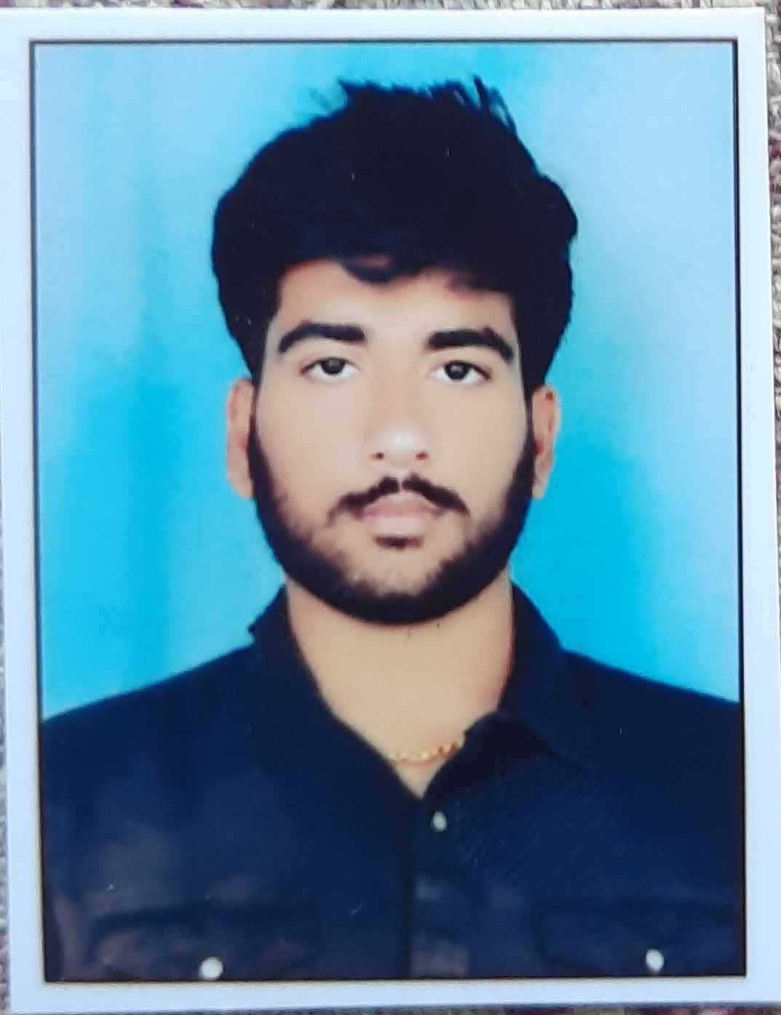

To prove myself dedicated, worthy and energeticas an engineer in a progressive organization that gives me scope to apply my knowledge and skills and be a member of a team, which dynamically works towards success and growth of the organization.

**Professional Qualification**

| **Qualification** | **University/ Board** | **College/ School** | **Year of passing** | **Percentage** |
| --- | --- | --- | --- | --- |
| B.Tech (Mech) | AMRITA school of engineering | AMRITA school of engineering | 2020 | 6 CGPA |
| Intermediate | Board of Intermediate Education | NRI | 2016 | 78 |
| S.S.C | Board of Secondary Education | Keshava Reddy | 2014 | 84.0 |

**Skills**

| Operating systems | Windows 98 /XP |
| --- | --- |
| Languages | HTML,CSS,JS,React,Node.js,mongodb |
| Tools | vscode |

**Main Project**

**Bio degradable plastics**

| **Description** | The main aim of the project is to create Biodegradable plastics.  These are plastics that can be decomposed by the action of living organisms, usually microbes, into water, carbon dioxide, and biomass. Biodegradable plastics are commonly produced with renewable raw materials, micro-organisms, petrochemicals, or combinations of all three. Resolved product issue through consumer testing. Collaborated with team of 4 in the development of producing bio degradable plastics. Adopted to the most recent techniques. |
| --- | --- |
| **Role** | Team Lead |
| **Team Size** | 04 |
| **Duration** | 3 Months |

**Mini Project**

**Fuel Cell Technology**

| **Description** | When we recall our life cycle, the problems we face generally are Pollution: With the day to day increase in our Technology and Urbanization, we are facing a very critical problem with pollution. We ourselves are opening the doors, inviting the pollution and destroying our valuable health and life. Fuel Consumption: World is facing a very critical crisis with a huge consumption of fuel for both our domestic and commercial purposes. So, its time for us to think beyond our scope and develop an environmental friendly resource for our consumption. The new technology has given us a valuable resource called “FUEL CELL” which will address the above problems and go hand in hand with our environment. With my interest after a deep study and analysis of it I have designed a sample Fuel Cell and verified its performance and output |
| --- | --- |
| **Role** | Individual Contributor |
| **Duration** | 2 Months |

**Industrial Training:**

**Manufacturing process of Industrial and Automotive Batteries**

| **Description** | Today in our daily life we have been using the Batteries in various fields like Domestic, Engineering, Industrial, Electronic and Transportation. So, Batteries are playing a key role in many fields and their usage has been increased enormously.  Keeping this importance in mind I have undergone an Industrial training in the AMARA RAJA BATTERIES LTD at Tirupathi which gave the precious opportunity to grab the knowledge on the manufacturing of automobile as well as industrialbatteries which is totally based on PLC controlling and totally automated process |
| --- | --- |
| **Role** | Team Lead |
| **Company Name** | Amara Raja Batteries Ltd.- Tirupathi |
| **Duration** | 02 weeks |
| **Team Size** | 05 |

**WebDevelopment Projects:**

**I am proficient in creating dynamic web pages using HTML,CSS and JS. Can deploy my projects in Github and netlify, I am also proficient in creating apps using reactjs and in backend i can develop servers using node.js and can combined it with the database created using mongodb using postman,**

**The following are my github and netify links so please go through them for better overview of my work.**

**Github: https://github.com/svr9493929001**

**Netlify:** [**https://app.netlify.com/teams/svr9493929001/overview**](https://app.netlify.com/teams/svr9493929001/overview)

**Codepen: https://codepen.io/srivardhanreddy-codepen**

**Extra Curricular Activities**

* Participation certificate for the technical paper on ‘Biometrics’ in National level student technical symposium at KSR College of engineering, Chennai.
* Participation certificate for the technical paper on ‘Fuel Cell Technology’ at Rajiv Gandhi Memorial College of engineering, Nandyala.
* Organized the technical Program, Industrial tour, social & cultural activities in school & college.
* Volunteer in blood and eye donation camp conducted in our college.

**Professional Strengths**

* Quick Learner and highly motivated.
* Ability to work independently and collectively to achieve the objectives.
* Enjoy challenging work environment.
* Meeting deadlines under dynamic situations and onsite pressure while delivering high quality.

**Declaration**

I consider myself familiar with the above-mentioned aspects. I am also confident of my ability to work in a team. I here by, declare that the information furnished above is true to the best of my knowledge.

Date: P SRI VARDHAN